A. MANAGING DIRECTORIES

1. Change the current directory to /home/<user>

We have to use the command cd, when you acces to the Terminal, you are currently on Home/user, so we can change to Desktop with the command cd Desktop and then go to home with: a) cd/home/ “user” or b) cd $HOME
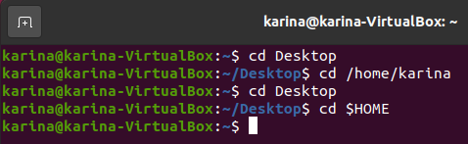

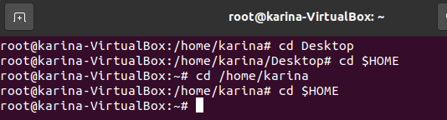

2. Create a directory called systems:
You can create directories with the command “mkdir”; you will need the command “tree” to see if it has created succesfully, so type tree, in my case, the machine indicates I have to install the commad with “sudo apt install tree and my password
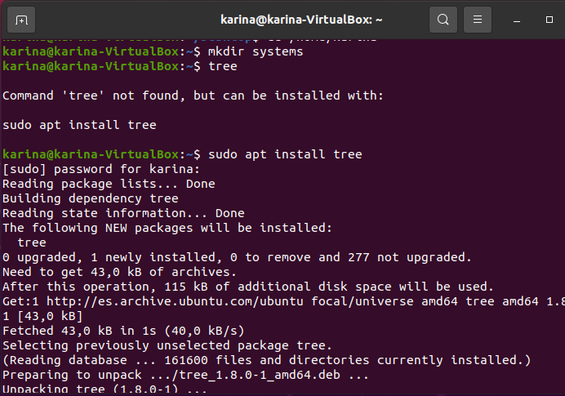

You type again tree and you will see the Directory “systems”
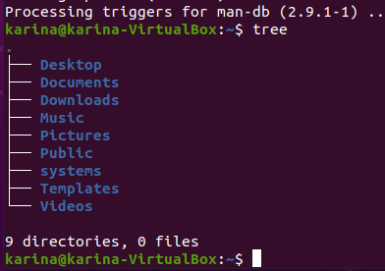

3. Create a directory called exercises. Go to this directory and create another new
directory called programming:

First you have to create the directory exercises with the command mkdir:
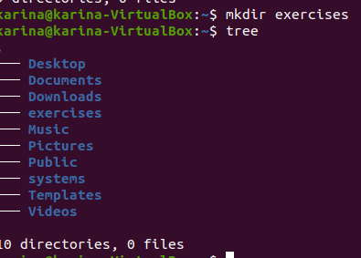

Then change to the directory exercises with the command cd exercises (remember you are in home) and now create “programming” with the command mkdir programming and tree to see the result:
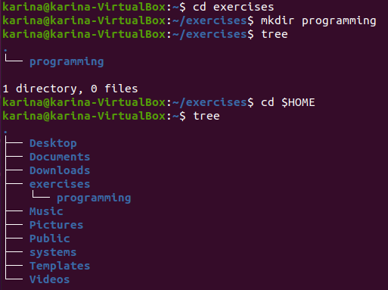

4. Go back to the user’s home directory. Delete the directories “exercises” and
“programming” using just one command. Create the directories again with one
command.

With the command tree, we check the directories:
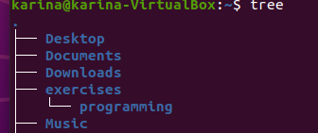

Now, we delete them with only one command, rm -rf exercises, we could use too rmdir -p exercises/programming:
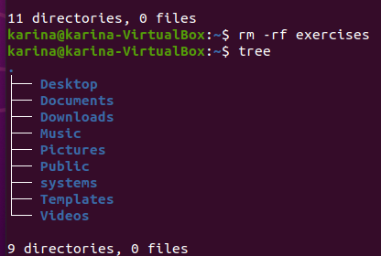

Now we have to created them again with only one command, we will use mkdir -p exercises/programming:
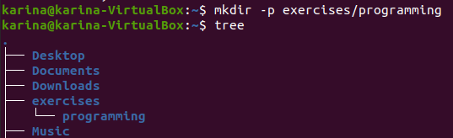

5. Print the contents of the root directory:
For printing the contents we use the command ls /:

6. Print all the files and directories that begin with d in the /usr/bin directory:
Use again the ls / and add /usr/bin and a d with , like this: ls /usr/bin/d*
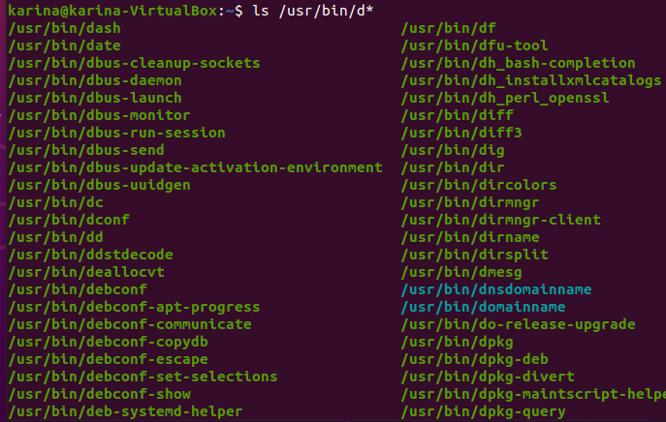

7. List all the files and directories in /etc, including subdirectories:
We use the command ls -R and add etc, like this: ls -R /etc:
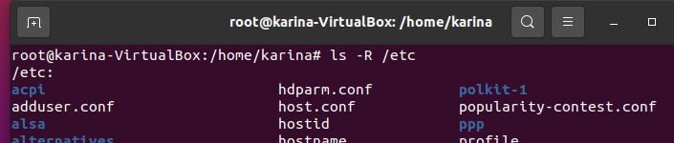

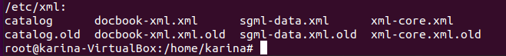

8. Create the empty files called student.txt, student1.txt, student2.txt, list, luggage and last
in the directory named “systems”:
First we change to directory systems with the command cd systems; then we verify the directory is empty with the command tree; then we create the empty files with the command touch and all the files’s names we want to create, like this: touch student.txt student1.txt….then we verify again with tree
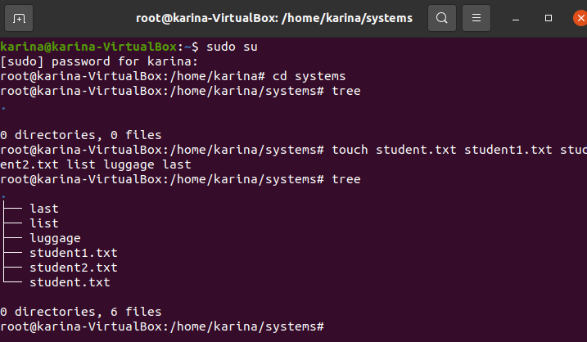

9. Print all the files that begin with “l” in the directory “systems”:
Again we use the command ls l*:
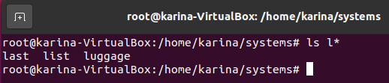

10. Print all the files that end with “txt” in the directory “systems”:
We use the same command but with the “*” at the end of txt, because we now require files ending with txt:
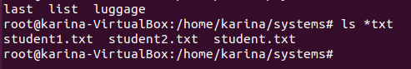

11. Create a new directory into $HOME called “config”:
As we are in systems, we are going to add to the command mkdir the directory $HOME, like this: mkdir $HOME/config; then we change to home with cd $HOME and finally check the new directory with the commands ls or tree:
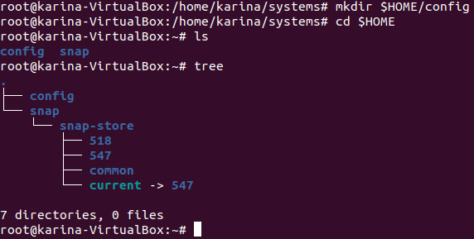

12. Copy all the files in /etc which begin with “a” into “config”:
We change to home directory with cd $HOME, then copy the files with the command cp /etc/a* config:
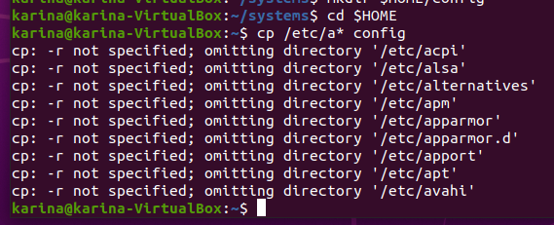

13. Delete all the files in “config” which end with “conf”:
We chage to the config directory with cd config; then we delete the files with the command rm *conf and finally check with tree:
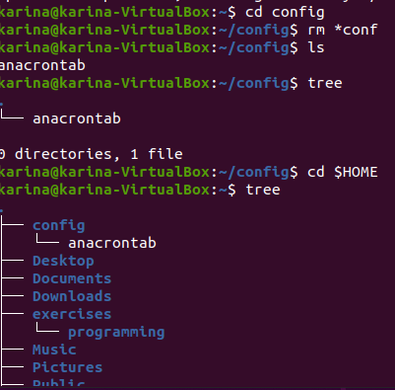

Create the following directory structure in /home/<user>/exercises

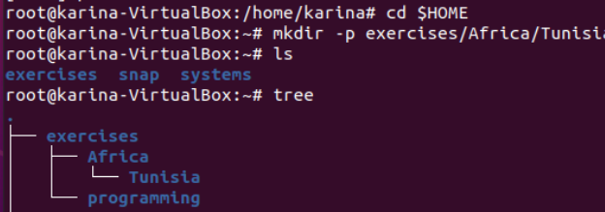

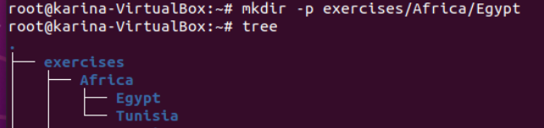

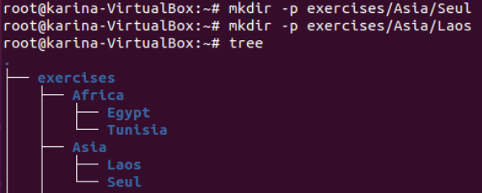

14. Create the following files using nano (or another editor): song.doc (write a few lines of
a song) in the directory Egypt; tv.doc (write the name of your favourite TV programs) in
the directory Seul and marks (write the marks you expect to get this year) in the
directory Tunisia.

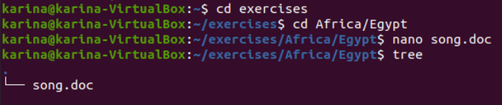

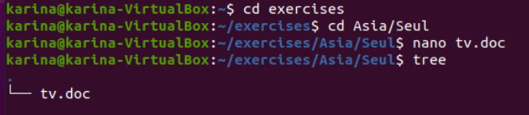

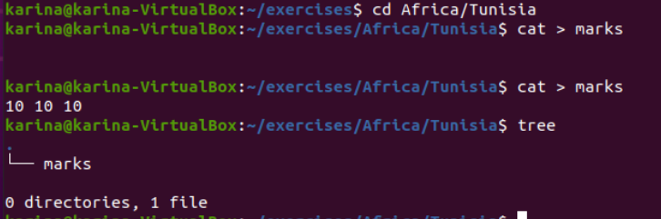

15. Copy the file “song.doc” into “Laos”
Change to $HOME with cd $HOME, then cd exercises, then cd Africa and copy with cp Egypt/song.doc ../Asia/Laos, then change again to Asia and tree to see the result:

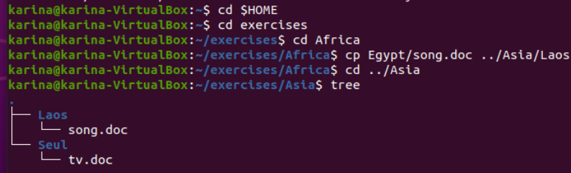

16. Copy the file “tv.doc” into “Egypt” with the name “radio.txt”:
Change with cd ../Africa and then cp ../Asia/Seul/tv.doc Egypt/radio.txt and then tree:

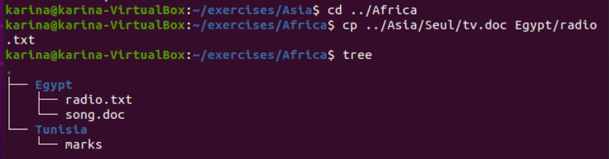

17. Rename the file “marks” to “exam.wri” (it is located in the directory named Tunisia):
We are going to move with the command: mv tunisia/marks tunisia/exam.wri

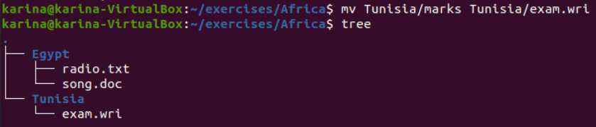
18. Copy the file “song.doc” (located in “Egypt”) inside “Tunisia”
We copy the file with the command: cp egypt/song.doc tunisia and then tree:

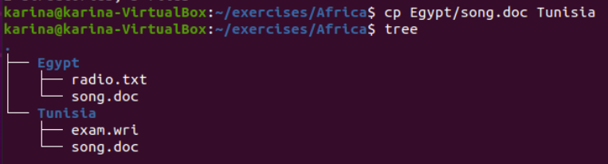
19. Print the content of the current directory using long listing format
We use the command ls -l to print the long list:

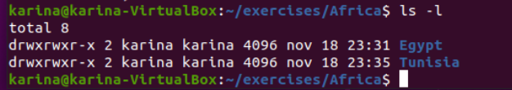
20. Rename the file “song.doc” (located in “Laos”) to “aa.doc”

Firts we use the command ls ../Asia/Laos and then move with the command:mv../asia/laos/song.doc ../asia/laos/aa.doc
and then ls ../Asia/laos

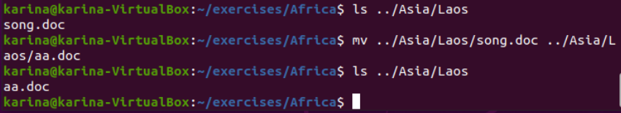

21. Create the directory “Others” in “Laos”

We create the directory with the command: mkdir ../Asia/Laos/Others:

22. Rename the directory named “programming” (which you created in the first exercises) to
pro-c.

23. Create the following directory tree in “exercises” (using as few commands as possible)
ONE
TWO THREE

24. Copy the files with txt extension from the directory named “systems” to “exercises”.

25. Move the files you copied in the exercise above to the directory THREE.

26. Delete the directory named THREE, including all the files and, if so, subdirectories

